FUEL TRACKING

THE PROBLEM:

Fuel is a very integral part of the transportation cost of any logistics provider. And hence, every service provider would want to save on fuel cost.

THE ENCOURAGEMENT:

A similar problem was faced by the company DHL Express. On employing a system called Vehicle Energy Reduction Program (VERP), they found that fuel could be saved by around 5% of the amount being currently expended on logistic operations in their case. Thus, we aim to develop a similar, low-cost solution, custom made for adaption to the domestic market.

Reference: <http://www.zdnet.com/article/dhl-drives-fuel-efficiency-with-driver-vehicle-tracking/>

ANALYSIS:

Fuel may be wasted through the following channels:

1. Pilferage: theft of fuel. This may happen:
2. Direct theft from the tank by opening the cap using suction pipes
3. Less amount filled into the tank at the station
4. Inefficient Use: the driving habits too determine the consumption of fuel. Erratic driving patterns like excess acceleration and braking, or non-optimum gear shifts may cause losses through this channel.
5. Unscheduled stops: the vehicle is stationary but the engine has not been turned off, and is still used for air-conditioning purpose or because of carelessness.
6. Non-optimum route chosen by driver

SOLUTIONS:

Keeping the above problems in mind, we may propose the following solutions respectively:

1. a) use proper caps with special locks and build that provide better security
2. Measure the volume of fuel in the tank before and after the refill
3. Use the GPS and the fuel-flow meter in tandem along with a system to detect what gear the vehicle is currently in, over a period of 2-3 weeks to generate data on driving patterns of drivers with the systems installed in the vehicle, and educate and sensitize them about the need for efficient driving
4. Once it is known that the vehicle makes unscheduled stoppages, the reasons and solutions can be worked out through dialogue.
5. Again, driver education and sensitization is required.

REALISING THE PROPOSED SOLUTIONS:

We may deliver upon the above mentioned solutions in the following ways:

1. Pilferage:
2. Cap Locks today are sophisticated in design and are built in such a way as to prevent theft by force. Use of electronic locks is discouraged since most systems used RFID, or small passcodes which are easy to hack by brute force attacks, and consume power for prolonged periods. Cap lock adapters are also available that are finely threaded to prevent leakage and fit in place of the original cap, just like a gear-lock is attached to a gear in a car. These locks have a large number of possible combinations, and thus are difficult to crack.
3. We may use anti-siphon valves that disable any suction of the fuel from the tank to the outside.
4. The volume measured before and after each refill can help us to detect the volume of fuel refilled, and we may easily detect any pilferage according to the sum of money the owner has allowed the driver for refill purpose.
5. Using the GPS and the fuel-flow meter we may find the real mileage of the vehicle and also use the GPS to find if there is erratic driving, in terms of sudden accelerations and braking, or whether the vehicle is being driven in the correct gear according to the speed it is being currently driven at.
6. GPS again is the solution for getting to know stoppages, and the GPS also provides the location of the stoppage that helps the system decide whether the stoppage is scheduled or not.
7. We may easily track the route taken by the driver through the constant GPS feeds, and may intervene whenever required.

SYSTEMS REQUIRED:

In order to accomplish the listed solutions, we require the following materials:

1. High accuracy GPS System:

Within 5, 10 or 15 meters, the accuracy required may be relaxed a bit depending upon the length of the vehicle, for example a car requires an accuracy of 5-8 m, while a trailer-truck may also do with a 20m accuracy.

1. Cap lock
2. Anti-siphon valve
3. Fuel-flow meter
4. Fuel volume indicator
5. A micro-controller to report to

This system proposes to just send the data acquired from the field to the cloud, whereas all the requisite calculations are expected to be done at the stationary system with the owner. Any indication required to be done expects commands from the cloud.

FUEL - FLOW METER

It is a sensor that is used to measure the amount of fuel flowing through from the tank to the engine. We may also use it just to measure the volume flowing into the engine, and use the data in from the fuel level meter also to find out if there is any theft or not. There are many types of electrical, optical and mechanical fuel flow meters which have been compared, and the Differential Flow Meters are the ones used most commonly for such purpose.

The following is a comparison of a few types of flow meters that are commonly used in the industry. This has been taken from a Texas Instruments support document.

<http://www.ti.com/lit/an/slyt471/slyt471.pdf>

<http://www.ti.com/solution/flow_meter>

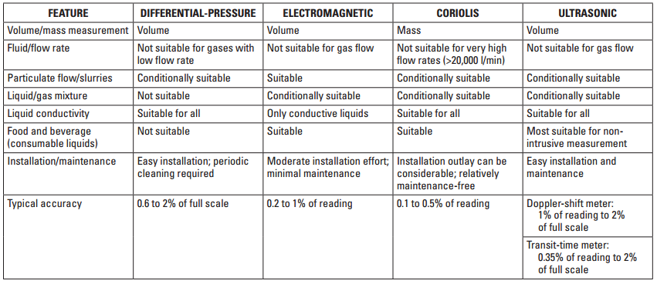

The following is a link to a commercial flow meter that is used for a similar purpose.

<http://technoton.in/fuel_flow_meter/fuel_counter.htm>

Some of its features worth noting are:

1. Immune to Magnetic Interference, and reports the time for which it was exposed to magnetic fields.
2. Doesn’t measure the flow of air and reports tampering time.

Differential Pressure Flow Meters: <http://www.tuvnel.com/_x90lbm/An_Introduction_to_Differential-Pressure_Flow_Meters.pdf>

According to Universal Flow Monitors, an industry-leader in the field of flow measurement, we can have the following types of DPFM for clean-oil measurement:

1. Vane style
2. Float style
3. Positive displacement
4. Coriolis Mass

Now, the Coriolis and the Float style may be easily eliminated from our choices since they would require conditions that can not be made available in a moving truck easily, or at a low cost.

We may chose between the remaining two:

<http://www.flowmeters.com/vane-style-for-clean-oil#catdesc>

<http://www.flowmeters.com/positive-displacement-for-clean-oil#catdesc>

FUEL - VOLUME INDICATOR

We will estimate the fuel volume by the level of fuel remaining in the tank that can be measured by the fuel level sensors. There are many kinds of sensors for this purpose that work on different principles.

A brief study is presented in the following link:

<http://www.engineersgarage.com/articles/what-is-level-sensor?page=1>

There are full commercial products available for such purpose.

CAP LOCK

ANTI - SIPHON VALVE